**Aim:**

Set up emulators to run FreeDOS.

**Description:**

Virtualization is creation of Virtual Machineswhich can emulate hardware in software or inother words it is the creation of virtual versionof something such as a hardware platform,operating system, storage device, or networkresources.

QEMU is a generic and open source machine emulator andvirtualizer.When used as a machine emulator, QEMU can run OSesand programs made for one machine (e.g. an ARM board)on adifferent machine (e.g. your own PC). By usingdynamic translation, it achieves very good performance.When used as a virtualizer, QEMU achieves near nativeperformances by executing the guest code directly on thehost CPU.

FreeDOS (formerly Free-DOS and PD-DOS) isan operating system for IBM PC compatiblecomputers. FreeDOS is made up of manydifferent, separate programs that act as"packages" to the overall FreeDOS Project.

COMMANDS:

|  |  |  |
| --- | --- | --- |
| Sl. No. | COMMAND | DESCRIPTION |
| 1. | sudo apt-get | To install |
| 2. | qemu-system --version | To see version number |
| 3. | cd | To navigate |
| 4. | create | To make the statement executable |
| 5. | boot | Boot the GUI |
| 6. | cdrom | Access bits in the CD |
| 7. | hda | Hard drive A |
| 8. | sudo | To give user permission |

**PROCEDURE:**

1. Installing qemu.
2. Install Freedos.
3. Move the files to common location.
4. Create image in qemu.
5. Boot freeDOS on qemu.

**Outputs:**

1. Installing qemu

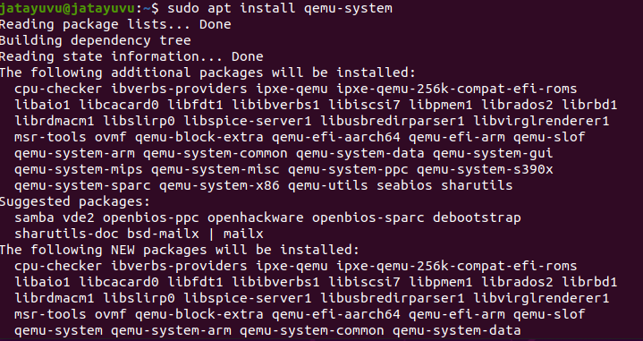

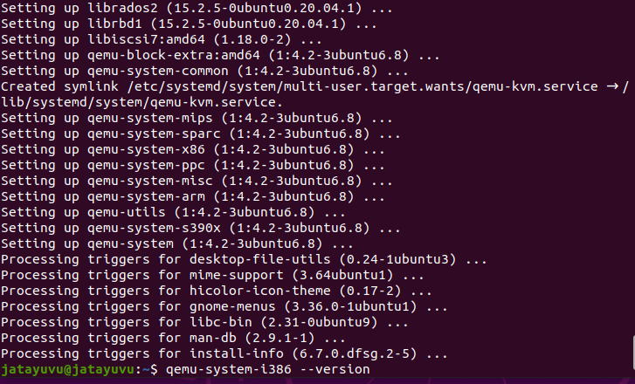

1. QEMU version



1. Downloading freeDOS

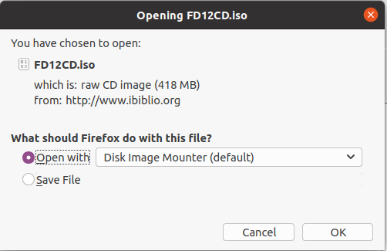

1. Making directory



1. Moving file



1. Creating image



1. Booting freeDOS on qemu

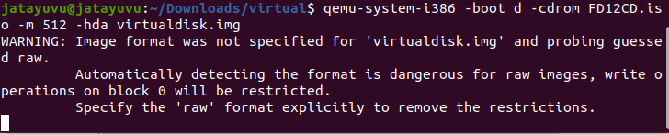

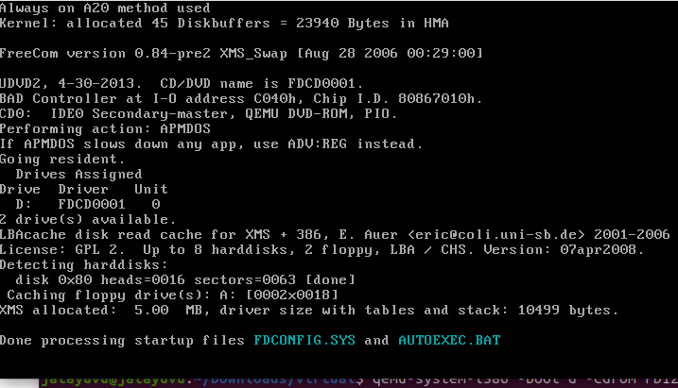

1. Setting up freeDOS

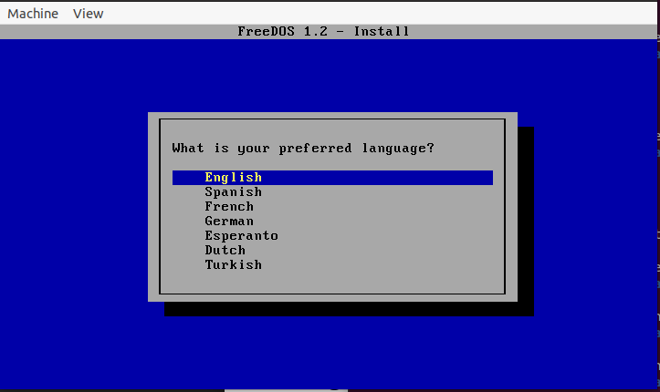

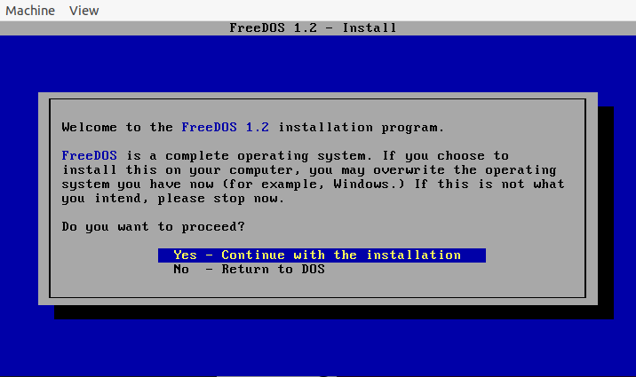

Video Link:

RESULT:

FreeDOS is being run on an emulator.